Courtney Mitra
Instructor Darlene Hadrika
DIG 4434C
5 May 2022

2D Fire Effect Technical Paper

I intended to place the 2D animated fire created by Yadi and I into the animation file in Maya. We decided that animated textures in Renderman were the best way to do this. I wanted to place the fire in a way that made it appear 3D. The following instructions show how I did this.

- Loop the fire animations in photoshop and repeat the loop for however may frames the shot needs, you may also need to adjust the animation so it doesn’t look unnatural when looped. (The flame animation had small sparks that flew off, those needed to be removed in the second half so it didn’t look like the flame was being played backwards on the loop)
- In the maya file, determine which frame each animated texture needs to start, If the animation starts after the first frame of the shot you will need blank frames until the animation starts in order to avoid a missing texture error.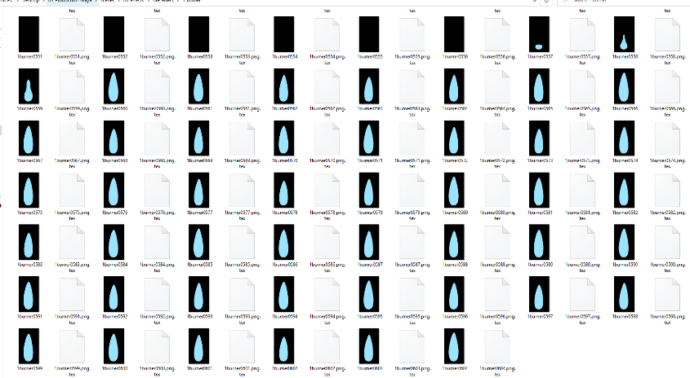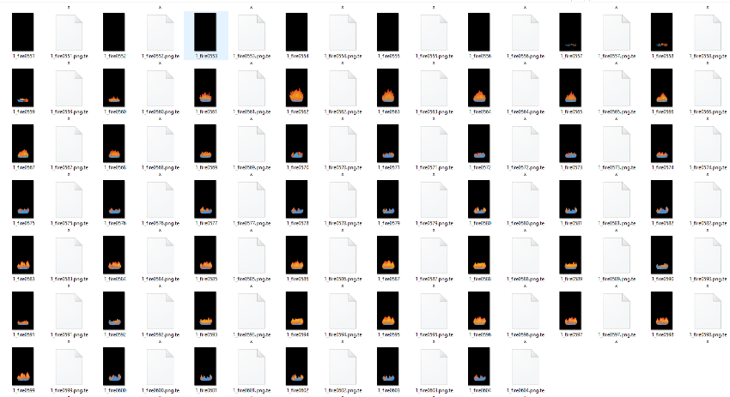
- After determining the frame each flame needs to start at, extend a blank layer frame in photoshop until the animation starts at the desired frame. You will need to export a diffent texture for all of the different timings.
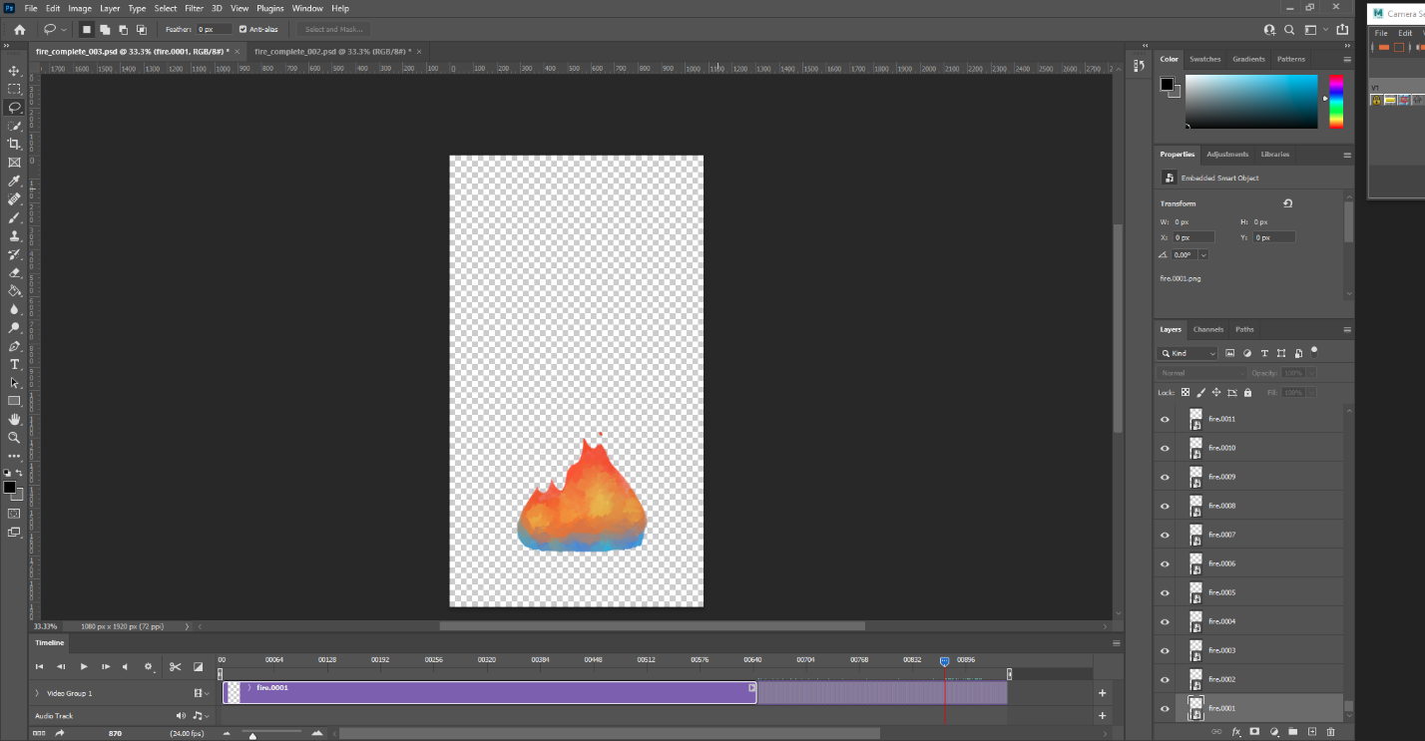
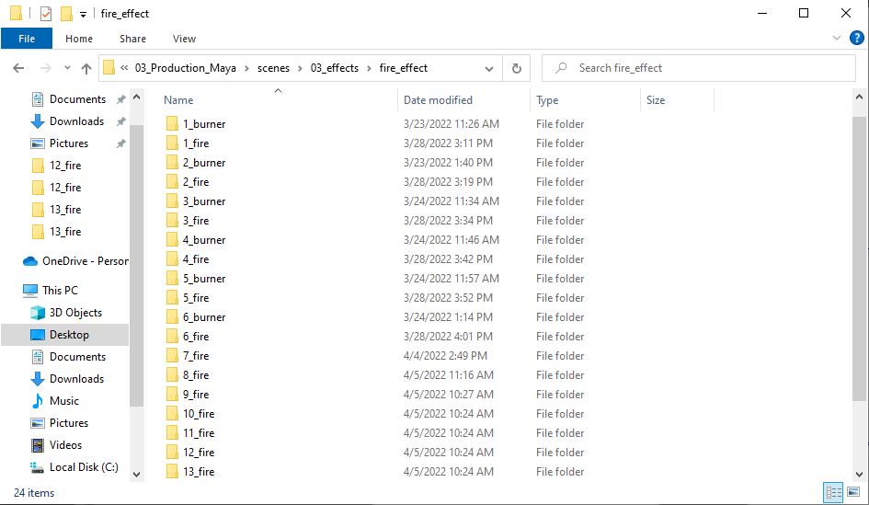
- Export the frames from photoshop, click File > export > render video, save the files at the size and location you want. Make sure to use a consistant naming convention and frame padding, and set the fps to 24. Also make sure to set the start and end frames to the exact length of the shot.
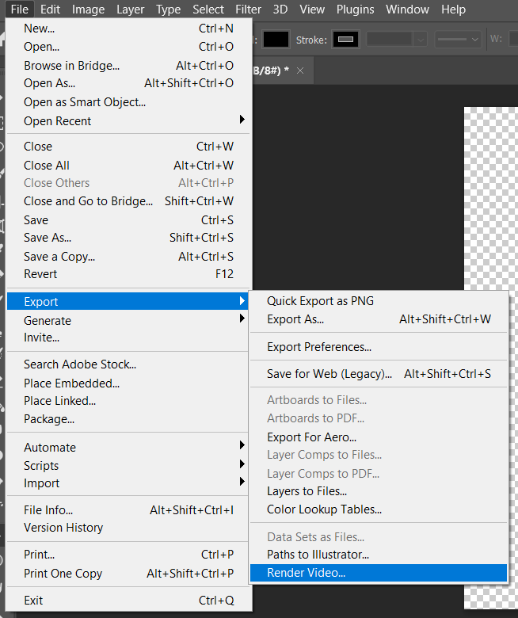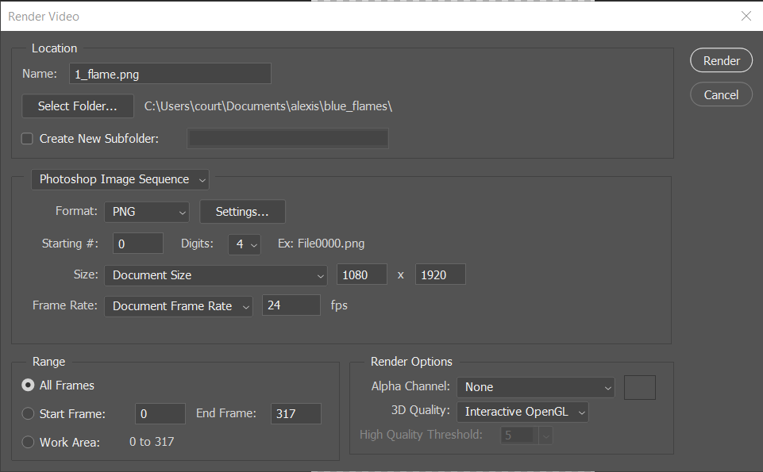

- Open a blank Maya scene and then create a reference of the Maya scene you want the flames in. Create a plane without any division in it. I decided to add a simple rig to the plane so it could be scaled and keyed without issue, you can do this by parenting it to a nurbs curve.
- After creating the plane assign right click the plane and choose assign new material, the navigate to Renderman materials and choose pxr surface.
- Name the surface something relevant to the texture you’ll be hooking it up to. Naming everything properly is important to making sure the connections don’t break later on.
- Open the texture in the hypershader, select the texture you just created in the material tab and click the box with two arrows . This will bring up the nodes, in a blank area next to the nodes hit tab and type pxrtextre, select the pxr textre node.
- Next rename the nodes to something relvant to the texture and start hooking them up. Start by connecting Result RGB to diffuse color. Then connect Result R to presence.
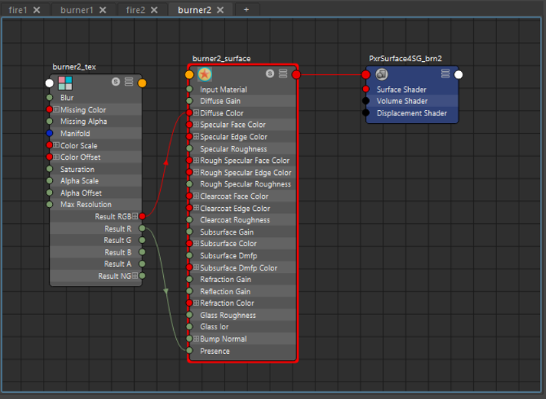
- Double click the pxrTexture node to bring it up the side of the hypershader, in diffuse color click the file and hook the texture up to the corresponding image sequence from photoshop. You can use IPR render to check if the texture is on the plane.

- In filename, change the frame padding number to <f4> so that Renderman knows it’s looking for an image sequence with a frame padding of 4.
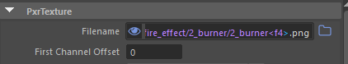
- Next you need to place the fire where it needs to be in the scene. I decide to create a file with only the fire planes so that lighting team could import the file and all of the fire would be in the correct place. You can duplicate the fire plane, right click, assign new material, and then repeat steps 6-11 to hook up the textures for the remaining flames (Some things will use the same texture, like the blue flames around the burner, you can right click and assign existing material for those).

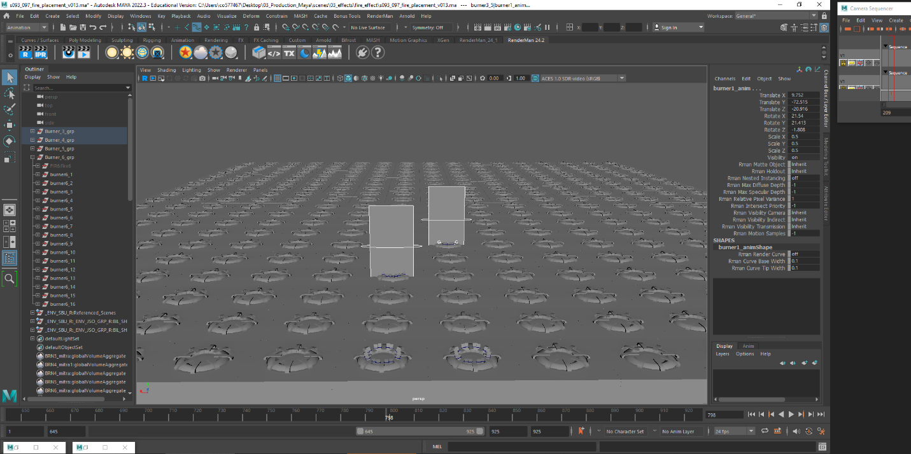
Flames placed in scene
- You can scale and rotate the flames as needed, in order to create a 3D effect with the 2D fire I arranged the flames in a way that would make them look 3D to the camera. This took trial and error as well as advice from the art directors and others.
Flames arranged around the burner
- When you are done placing the flames unload the reference and save the file. The file can be imported into the animation file when its needed.
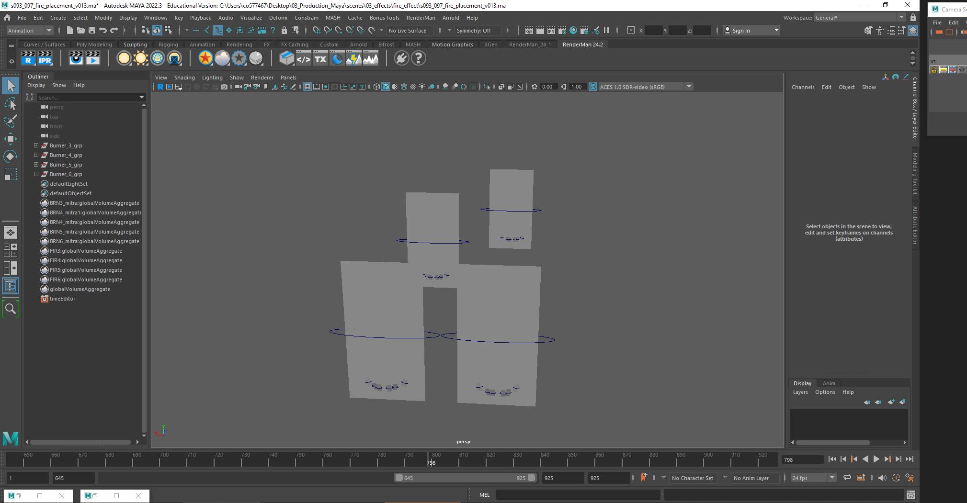
Flames in their own file
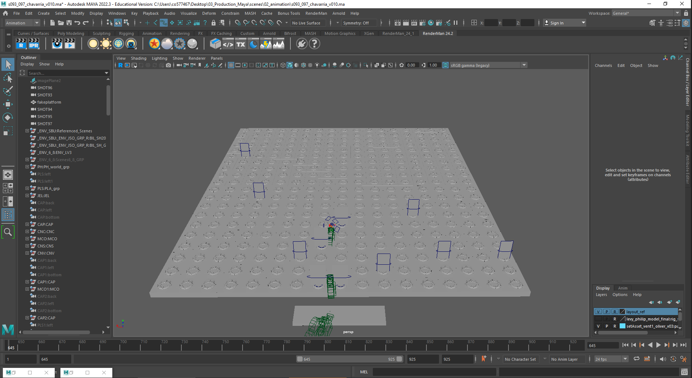
Flames imported
- In the compositing stage in Nuke each flame can be selected with a cryptomatte this will allow the compositor to add effects like the glow node if needed.

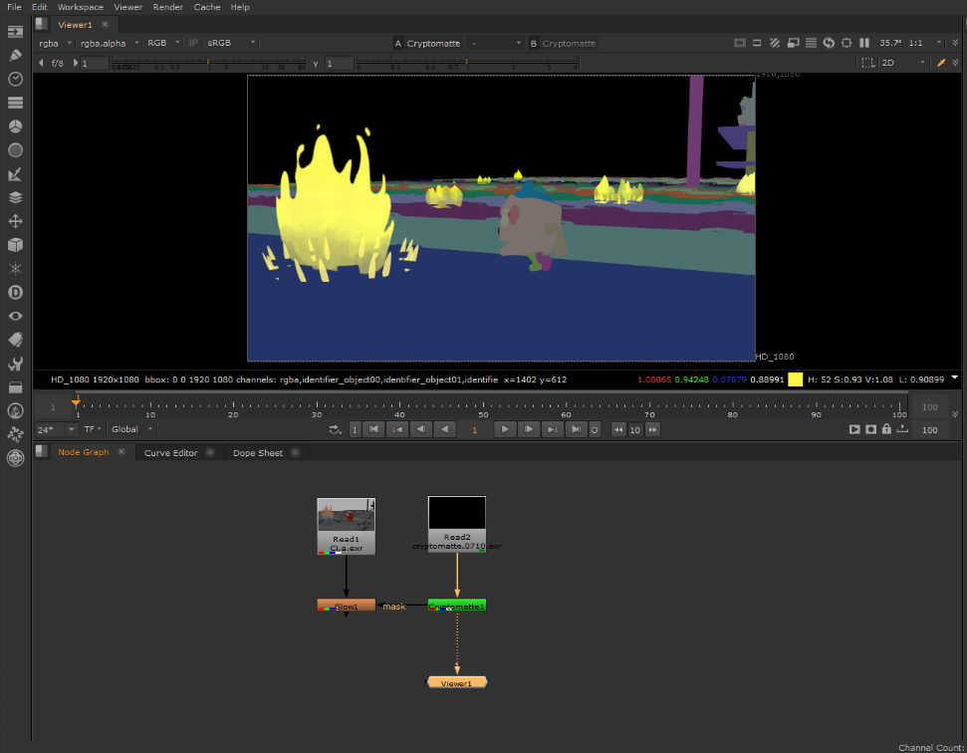
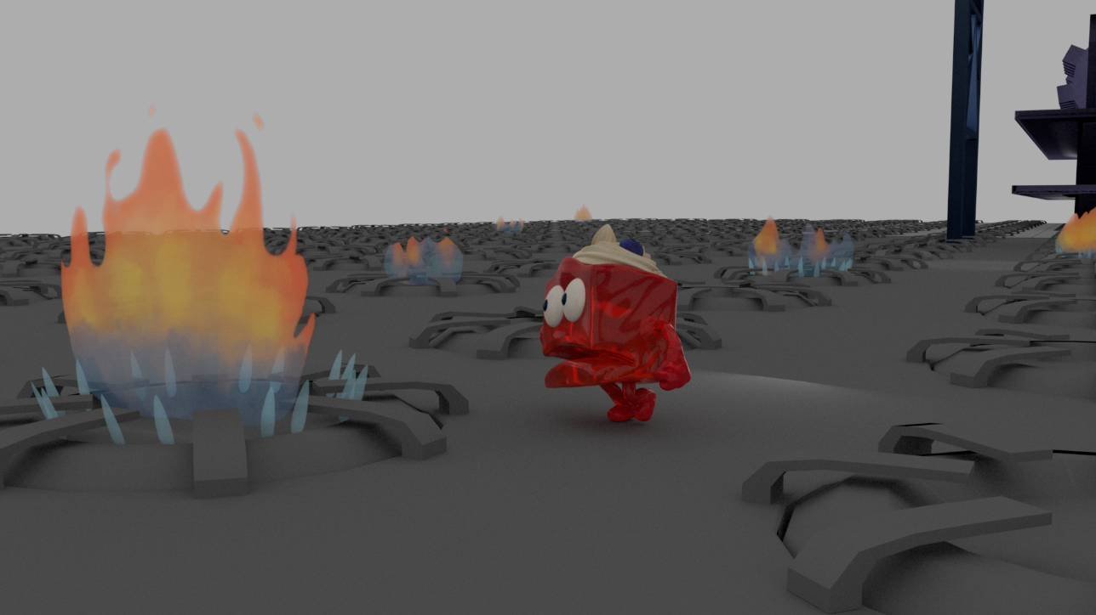

For this effect I referenced another technical paper and the other tutorials, after going through the technical paper and tutorials I was able to hook up the textures in Maya. While working on this effect I discovered a way to allow multiple flames appear in the scene at once as well as start at different times. I also found a way to make the flames not appear as 2 dimensional so that they wouldn’t be distracting in the scene. While working on this effect, I found that naming convention is very important, one day the flames disconnected and I could not reconnect them, to fix this I made sure that my naming convention was consistent and renamed everything involving the flames, like the texture nodes. This appeared to fix the problem. Since the scene was so long the files for the textures took up a lot of space on my computer, to help with this I decided to only use the smaller blue flames on burners closest to the camera, this helped me conserve space. Another issue was that the 2D planes looked a bit flat, I found that angling the blue flames slightly helped a lot to make them appear more 3D.

Works Cited
Chavarria, Yadira. Project: 3B Tech Paper. Orlando, 2021.
Rew, Michael. "Small Robot Studio." 25 January 2017. YouTube. https://www.youtube.com/watch?v=NaYqya2csEE. 12 March 2022.
Rew, Micheal. "Small Robot Studio." 18 September 2020. YouTube. https://www.youtube.com/watch?v=NaYqya2csEE. 12 March 2022.

